Part I – Working with an existing database

# Setting up Oracle Chinook

In this section you will begin the process of working with the Oracle Chinook database

Task – Open the Chinook_Oracle.sql file and execute the scripts within.

## 2.0 SQL Queries

In this section you will be performing various queries against the Oracle Chinook database.

## 2.1 SELECT

Task – Select all records from the Employee table.

Answer:-set Schema 'chinook';  
SELECT * FROM "Employee";

Task – Select all records from the Employee table where last name is King.

Answer:-set Schema 'chinook';  
SELECT * FROM "Employee"   
WHERE "LastName" = 'King';

Task – Select all records from the Employee table where first name is Andrew and REPORTSTO is NULL.

Answer:-set Schema 'chinook';  
SELECT * FROM "Employee"   
WHERE "FirstName"= 'Andrew'  
AND "ReportsTo" IS null;

## 2.2 ORDER BY

Task – Select all albums in Album table and sort result set in descending order by title.

Answer:-set Schema 'chinook';  
SELECT * FROM "Album" ORDER BY "Title" DESC;

Task – Select first name from Customer and sort result set in ascending order by city

Answer:-set Schema 'chinook';  
SELECT * FROM "Customer" ORDER BY "City" ;

## 2.3 INSERT INTO

Task – Insert two new records into Genre table

Answer:-set Schema 'chinook';  
INSERT INTO "Genre" ("GenreId","Name")  
VALUES(26,'UDAY');

TO CHECK IT USE THIS QUERY: SELECT*FROM "Genre";

Task – Insert two new records into Employee table

Answer:-set Schema 'chinook';  
INSERT INTO "Employee" ("EmployeeId", "LastName", "FirstName", "Title", "BirthDate", "HireDate", "Address", "City", "State", "Country", "PostalCode", "Phone", "Fax", "Email") VALUES

(9,'Jain','Uday','Manager','1983/04/22', '2012/01/28','544 Siena Lane','Glen Allen','VA','USA','23059','+1 (703) 340-5353','+1 (804) 284 1659', 'uday.jain@capitalone.com');

(10,'Jain','Sneha','Sr.Manager','1987/08/26', '2012/12/18','544 A Siena Lane','Glen Allen','VA','USA','23060','+1 (703) 677-4524','+1 (804) 284 1000', 'sneha.jain@capitalone.com');

(11,'Jai','Uda','Sales Manager','6','1988/04/22', '2014/01/28','15000 capitalone Lane','richmond','VA','USA','23059','+1 (703) 340-5113','+1 (804) 284 2659', 'udayjain@gmail.com')

Task – Insert two new records into Customer table  
Answer:-set Schema 'chinook';  
INSERT INTO "Customer"("CustomerId", "FirstName", "LastName", "Company", "Address", "City", "State", "Country", "PostalCode", "Phone","Fax","Email","SupportRepId")

VALUES ('60','Uday','Jain','Capitalone','15080 Capitalone Drive','Richmond','VA','USA','23238','(+1) 703 340 5353','+1 278 333 8363','uday.jain@capitalone.com','1');

VALUES ('61','Sneha','Jain','Capitalone','15070 Capitalone Drive','Richmond','VA','USA','23060','(+1) 703 677 4524','+1 978 333 8923','sneha.jain@capitalone.com','2');

## 2.4 UPDATE

Task – Update Aaron Mitchell in Customer table to Robert Walter  
Answer:-   
This way change the old name to new name  
set Schema 'chinook'  
UPDATE "Customer" SET "FirstName" ='Aaron', "LastName" = 'Mitchell'  
Where "FirstName" ='Robert'AND "LastName" = 'Walter';  
  
This way I used the customer id   
set Schema 'chinook'   
UPDATE "Customer" SET "FirstName" ='Robert', "LastName" = 'Walter'   
Where "CustomerId" = 32

Task – Update name of artist in the Artist table “Creedence Clearwater Revival” to “CCR”  
Answer:-set Schema 'chinook';  
UPDATE "Artist"  
SET "Name" ='CCR'  
WHERE "Name" ='Creedence Clearwater Revival';

SELECT * FROM "Artist"  
WHERE "Name" ='Creedence Clearwater Revival';

## 2.5 LIKE

Task – Select all invoices with a billing address like “T%”  
Answer:-set Schema 'chinook';  
SELECT * FROM "Invoice"  
WHERE "BillingAddress" like 'T%';

## 2.6 BETWEEN

Task – Select all invoices that have a total between 15 and 50  
Answer:-set Schema 'chinook';  
SELECT * FROM "Invoice"  
WHERE "Total" BETWEEN 15 AND 50;

Task – Select all employees hired between 1st of June 2003 and 1st of March 2004  
Answer:-set Schema 'chinook';  
SELECT * FROM "Employee"  
WHERE "HireDate" BETWEEN '2003/06/01' AND '2004/03/01';

## 2.7 DELETE

Task – Delete a record in Customer table where the name is Robert Walter (There may be constraints that rely on this, find out how to resolve them).  
Answer:- set Schema 'chinook'

1. Delete from InvoiceLine based on InvoiceID  
   DELETE FROM "InvoiceLine"  
   Where"InvoiceId" IN (50,61,116,245,268,290,342);
2. Delete from Invoice based on InvoiceID  
   DELETE FROM "Invoice"  
   Where"InvoiceId" IN (50,61,116,245,268,290,342);
3. Delete from Customer Table   
   Delete FROM "Customer"  
   WHERE "FirstName" ='Robert' AND "LastName" = 'Walter';

# 7.0 JOINS

In this section you will be working with combing various tables through the use of joins. You will work with outer, inner, right, left, cross, and self joins.

## 7.1 INNER

Task – Create an inner join that joins customers and invoice and specifies the name of the customer and the invoiceId.  
Answer:-set Schema 'chinook';  
SELECT * FROM "Customer" as cust   
INNER JOIN "Invoice" as iid ON(iid."CustomerId" = cust."CustomerId")  
Where "FirstName"= 'Frank' And "InvoiceId" =13;

## 7.2 OUTER

Task – Create an outer join that joins the customer and invoice table, specifying the CustomerId, firstname, lastname, invoiceId, and total.

Answer:-set Schema 'chinook';  
SELECT * FROM "Customer" as cust   
FULL JOIN "Invoice" as iid ON(iid."CustomerId" = cust."CustomerId")  
Where "FirstName"= 'Frank'  
AND "LastName" ='Harris'  
And "InvoiceId" =13  
And "Total" = 0.99;

## 7.3 RIGHT

Task – Create a right join that joins album and artist specifying artist name and title.  
Answer:-set Schema 'chinook';  
SELECT * FROM "Album" as alb   
Right JOIN "Artist" as art ON(alb."ArtistId" = art."ArtistId")  
WHERE "Name"= 'Accept'  
AND "Title" = 'Balls to the Wall';

## 7.4 CROSS

Task – Create a cross join that joins album and artist and sorts by artist name in ascending order.

Answer:-set Schema 'chinook';  
SELECT * FROM "Album"  
CROSS JOIN "Artist"  
WHERE "Name"= 'Accept';

## 7.5 SELF

Task – Perform a self-join on the employee table, joining on the reportsto column.

Answer:- set Schema 'chinook';  
SELECT * FROM "Employee" a,"Employee" b  
Where a."ReportsTo" = b."ReportsTo";

# 8.0 Indexes

In this section you will be creating Indexes on various tables. Indexes can speed up performance of reading data.

## 8.1 Clustered Indexes

Task – Create a clustered index on of table of your choice

Answer:-set Schema 'chinook';  
Create Index Assignmet2 on "Employee"("EmployeeId","FirstName", "LastName");ß

Part II – Creating and working with your own custom database

# Creating the OfficeSupply Database

Objective: In this section you will be creating a database based on information given to you in this handbook.

## 1.1 Create Company Database using SSMS Interface

Task – Create a user and name it “OfficeSupply” in Oracle Web Console

Task – Delete the OfficeSupply user

## 1.2 Create Company Database using DDL

Task – Create a user and name it “OfficeSupply” using DDL (SQL Script in SQL Developer)

# Creating Tables and Relationships

Objective: In this section you will be creating tables for the OfficeSupply database, you will create attributes and corresponding datatypes. You will also create relationships between the tables.

## 2.1 Create Tables for OfficeSupply

Task – Using the DDL, create a table named “Employees” with following attributes and datatypes:

EmployeeID(PK number, not null), UserName(varchar(20), not null), Password(varchar(20), not null),

Name(varchar(25), not null), Department(char(2), not null), Manager(number, not null).

Task – Using the DDL, create a table named “Orders” with following attributes and datatypes:

OrderID(PK, number, not null), EmployeeID(FK, number, not null), OrderDate(date, not null), Status(char, not null).

Task – Using the DDL, create a table named “OrderItem” with the following attributes and datatypes:

OrderID(PK, FK, number, not null), ProductID(PK, FK, number, not null), Quantity(number, not null).

Task – Using DDL, create a table named “Category” with the following attributes and datatypes:

CatID(PK, number, not null), Name(varchar(80), null), Descript(varchar(255), null)

Task – Using DDL, create a table named “Product” with the following attributes and datatypes:

ProductID(PK, number, not null), CatID(FK, number, not null), Name(varchar(80), null), Descript(varchar(255), null),

UnitCost(number, null), SuppID(FK, number, not null).

Task – Using DDL, create a table named “Supplier” with the following attributes and datatypes:

SuppID(PK, number, not null), Name(varchar(80), null).

## 2.2 Creating Relationships

Task – Create a 1:N relationship between Employees(PK) and Orders(FK)

Task – Create a 1:N relationship between Orders(PK) and OrderItem(FK)

Task – Create a 1:N relationship between Product(PK) and OrderItem(FK)

Task – Create a 1:N relationship between Supplier(PK) and Product(FK)

Task – Create a 1:N relationship between Category(PK) and Product(FK)

# Performing SQL Queries

Objective: In this section you will be querying and performing CRUD operations on the OfficeSupply database using various DML and SQL statements *Before you begin performing queries against your database, enter into your tables, the following data exactly as shown in the images:

**Employee Table**

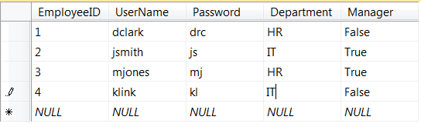

**Product Table**

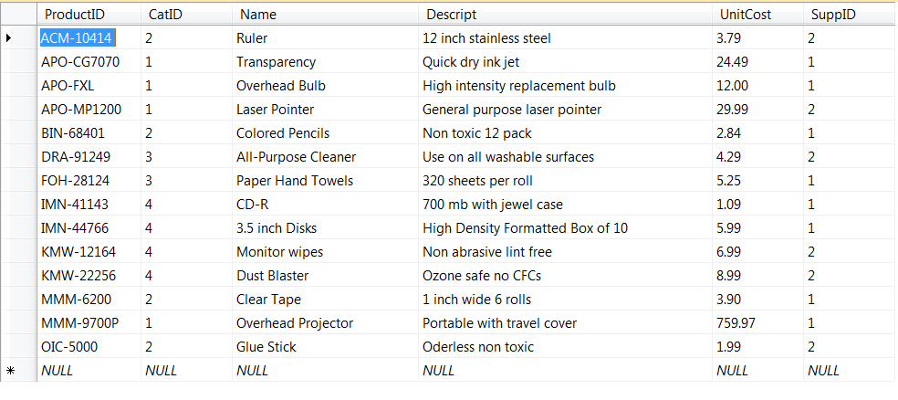

**Supplier Table**

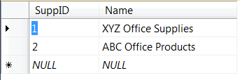

**Category Table**

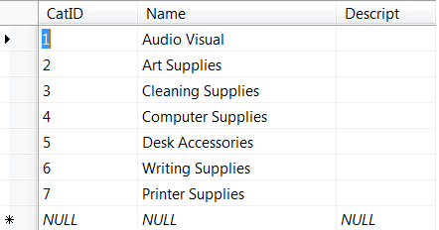

## 3.1 SELECT

Task – Select all the rows from the employees table

Task – Select all the rows from the employees table where the Department is HR

Task – Select all the rows from the employees table where username is jsmith and department is HR

Task – Select all the rows from the employees table where manager is true or department is HR

## 3.2 ORDER BY

Task – Select name from product table and order by name in ascending order.

Task – Select name from product table and order by name in descending order.

Task- Select all records from category table order by name.

## 3.3 INSERT INTO

Task – Insert a new row into the employees table.

Task – Insert into a new row into the category table

Task – Insert three records into the supplier table.

## 3.4 UPDATE

Task – Update unit cost in products table where name is ruler

Task – Update the description of computer and cleaning supplies in the Category table.

## 3.5 LIKE

Task – Select username from employees table where username is like “j”

Task – Select name from product table where name is like “O”

## 3.6 BETWEEN

Task – Select name from products table where unitprice is between 3 and 10

Task – Select name from products table where unit price is between 500 and 800

## 3.7 DELETE

Task – Delete a record from the category where the value is audio visual

Task – Delete the three records you previously inserted into the supplier table

# SQL Functions

In this section your will be using the system defined functions built into Oracle 10g as well as creating your own user defined functions

## 4.1 System Defined Scalar Functions

Task – create a function that returns the length of the string of the description of the laser pointer

Task – Create a function the converts a username in the employees table to upper case.

## 4.2 System Defined Aggregate Function

Task – Create a function that gets the sum of the unitprice column from the products table

Task – Create a function that gets the count of all the products in the products table

## 4.3 User Defined Scalar Functions

Task – Create a function that takes two inputs (unit price of products) and calculates the cost of the two products

## 4.4 User Defined Table Valued Functions

Task – Create a function that returns whether or not a username belongs to a manager

# Stored Procedures

In this section you will be creating stored procedures, including stored procedures that have input and output parameters, and return values.

## 5.1 Basic Stored Procedure

Task – Create a store procedure that returns all employees with the username, dept, and manager columns from the employees table. Call the procedure to get the result set.

Task – Create a stored procedure that returns all the products with the name, and unitprice column from the products table.

## 5.2 Stored Procedure Input Parameters

Task – Create a stored procedure that takes in a productID and gets the name and description of that productID

Task – Create a stored procedure that insert a new manager into the employees table

## 5.3 Stored Procedure Output Parameters

Task – Create a stored procedure that calculates the value of the unit cost column in the products table and returns the total amount

Task – Create a procedure that would return username and password based on employeeID

# Transactions

In this section you will be working with transactions. Transactions are usually nested within a stored procedure and contain exaction handling functionality. You will also work with error handling in a transaction.

Task- Create a transaction that is nested inside a stored procedure that inserts a new record into the employees table.

Task – Create a transaction that is nested inside a stored procedure that updates the untitprice of a product in the products table.

Task – create a multi-statement transaction nested in a stored procedure that updates at least two records’ name and description in the category table

# Triggers

In this section you will be creating triggers on various tables. You will work with AFTER/FOR triggers and INSTEAD OF triggers.

## 7.1 AFTER/FOR Triggers

Task - Create an after insert trigger on the categories table fired after a new record is inserted into the table.

Task – Create an after update trigger on the categories table that fires after a row is inserted in the table

Task – Create an after delete trigger on the categories table that fires after a row is deleted from the table.

## 7.2 INSTEAD OF Triggers

Task – create an instead of delete trigger on the Products table that restricts the deletion of any records that are priced below 500 dollars.

# JOINS

In this section you will be performing joins on various tables. You will to populate each table with data. Pay attention to keys and referential integrity when inserting data into your tables.

## 8.1 INNER JOIN

Task – Perform an inner join on tables product and category

Task – Perform an inner join on tables employee and orders

## 8.2 OUTER JOIN

Task – Perform an outer join on tables products and orderitems

Task – Perform an outer join on tables employee and orders

## 8.3 RIGHT JOIN

Task – Perform a right join on tables orders and orderitems

Task – Perform a left join on tables product and orderitems

## 8.4 LEFT JOIN

Task – Perform a left join on tables product and category

Task – Perform a left join on tables employees and orders

## 8.5 CROSS JOIN

Task – Perform a cross join on tables product and category

## 8.6 SELF-JOIN

Task – using the employees table perform a self-join. You can break up the table as needed.

# Views

View can be thought of as virtual tables. In this section you will create views to enhance the security of your database.

Task – create two new columns named SSN and salary on the employees table. Create a view that displays all columns except SSN and salary

Task – Create a view on the products table that only displays only the name of the product and the description.

# Indexes

In this section you will be creating Indexes on various tables. Indexes can speed up performance of reading data.

## 10.1 Clustered Indexes

Task – Create a clustered index on of table of your choice

# Administration

In this section you will be creating backup files of your database. After you create the backup file you will also restore the database.

Task – Create a .bak file for the OfficeSupply database